The Code has been explained with comments if needed here are just run of the program:

First excersize

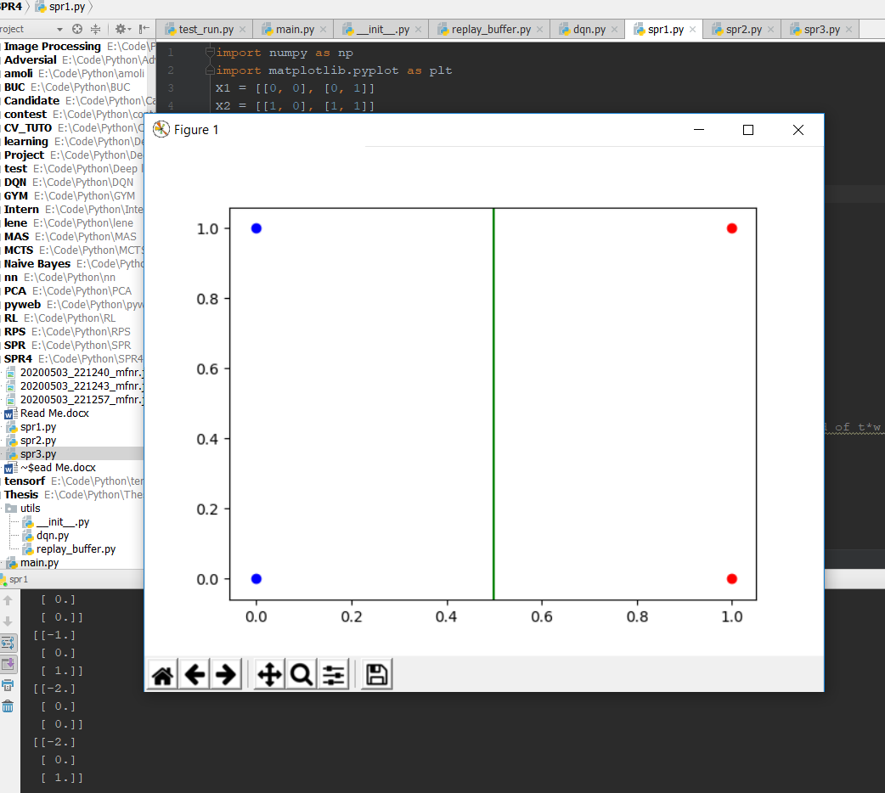

Also as we can see the w changes in:

[[0.]

[0.]

[0.]]

To

[[-1.]

[ 0.]

[ 0.]]

To

[[-1.]

[ 0.]

[ 1.]]

To

[[-2.]

[ 0.]

[ 0.]]

To

[[-2.]

[ 0.]

[ 1.]]

Second exercisess:

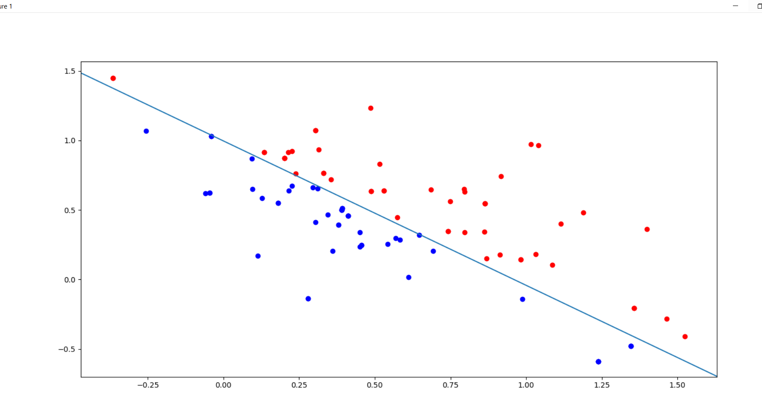

Last exercise:

